Final Project Report - Digital Theremin

**Procedure**

For this project, we started with what we had already built based on previous labs. This included using UART2 to communicate with the terminal and UART1 to communicate with one of the distance sensors. Our original circuit with the speaker was kept the same.

UART3 was instantiated to communicate with the second distance sensor to control volume. The settings were kept nearly the same as UART1, including the following: 8 data bits, 1 stop bit, no parity bit, and oversample by 8. We also kept the same Baud rate, 9600.

We reorganized our code to use a Gatekeeper task to control the communication with UART2, this way UARTS 1 & 3 weren’t competing for the resource. A queue was created to control the volume, which would then divide the value in the volume LUT, and therefore output a smaller amplitude on the DAC. For volume, we ended up having 8 discrete values.

A UART control task was created to manage the values coming in from UARTs 3 and 1, and decide which notes will be played on the speaker.

**Results**

Since we first built on lab 4, which wasn’t working properly, we had a difficult time getting started. Our UART was not reporting distance values correctly. After adding another event check for the UART buffer, we were able to get both temperature and distance.

We were initializing UART 3 based on the textbook, which apparently gave us incorrect values. Eventually we found the correct pins for UART3 and were able to initialize them properly and change volume.

Our biggest setback ended up being the output from the DAC. We were able to see what volume values should be sent to the DAC, but it wasn’t playing through the speaker anymore. We then checked the queue receive and queue message functions with the listed functions on the FreeRTOS website. The problem was because we used uxQueueMessagesWaiting function instead of uxQueueMessagesWaitingFromISR function. Once we changed to the ISR function the DAC would change volume and we got sound.

**Figures**

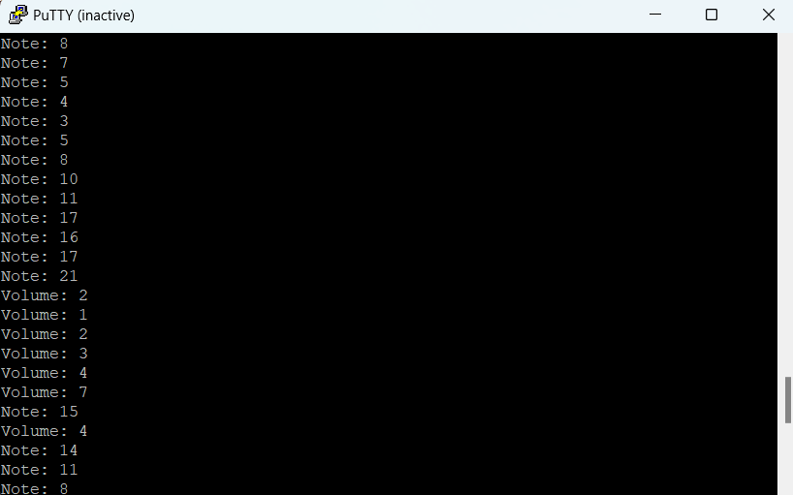

Figure 1. PuTTY Terminal Output

**Conclusion**

In conclusion, our project was to build a digital theremin. This project used two ultrasonic sensors for measuring distance. The distance values would then determine which note and volume the speaker would play. For this project we also had to use a resource protection method discussed in class. We chose to use a gatekeeper task to protect the UART resource that communicates to the computer. It was a fun project that we learned a lot through.